# Lab 1

In this lab you will build and test a night light circuit using an LED and a Light Dependent Resistor.

## Step 1

[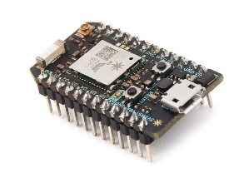](https://www.google.com/url?sa=i&rct=j&q=&esrc=s&source=images&cd=&cad=rja&uact=8&ved=2ahUKEwj49ZCggsLaAhUL24MKHeT0CvMQjRx6BAgAEAU&url=https://www.seeedstudio.com/Particle-Photon-p-2527.html&psig=AOvVaw2GyAksMO7fUTrEVD1Z9NaQ&ust=1524078837631976)Place the Photon microcontroller on the breadboard with the USB plug again the edge labeled 1.

## Step 2

[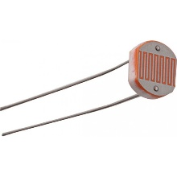](https://potentiallabs.com/cart/ldr-india)Insert one pin of the **Light Dependent Resistor** into position **A1** on the breadboard. Insert the other end of the LDR into **A12**. *This is a symmetric component, so it does not matter which way it is placed into the board.*

## Step 3

[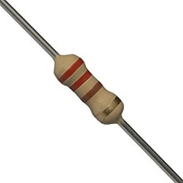](https://www.google.com/url?sa=i&rct=j&q=&esrc=s&source=images&cd=&cad=rja&uact=8&ved=2ahUKEwjDqebugcLaAhUO8YMKHQ1KD90QjRx6BAgAEAU&url=https://www.amazon.in/220-carbon-film-resistor-resistance/dp/B01N9AQ5L8&psig=AOvVaw3hSNT6vbgMBL7C1233hSgJ&ust=1524078727721363)Insert one pin of the first **220 Ω Resistor** (there are two in the package) into position **B2** on the breadboard. Insert the second pin of the resistor into **B12**. *This is a symmetric component, so it does not matter which way it is placed into the board.*

## Step 4

[](https://www.google.com/url?sa=i&rct=j&q=&esrc=s&source=images&cd=&cad=rja&uact=8&ved=2ahUKEwjDqebugcLaAhUO8YMKHQ1KD90QjRx6BAgAEAU&url=https://www.amazon.in/220-carbon-film-resistor-resistance/dp/B01N9AQ5L8&psig=AOvVaw3hSNT6vbgMBL7C1233hSgJ&ust=1524078727721363)Insert one pin of the second **220 Ω Resistor** into position **I4** on the breadboard. Insert the second pin of the resistor into the **-** rail (blue) on the same side (close to I4). *This is a symmetric component, so it does not matter which way it is placed into the board.*

## Step 5

[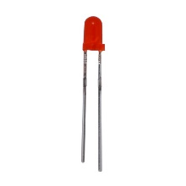](https://www.google.com/url?sa=i&rct=j&q=&esrc=s&source=images&cd=&cad=rja&uact=8&ved=2ahUKEwibjsyIg8LaAhVK_IMKHci6A7UQjRx6BAgAEAU&url=https://www.bananarobotics.com/shop/Basic-Red-LED-3mm-(10-pack)&psig=AOvVaw0rNMF8gRnQ3X1KB3NNnXvl&ust=1524079052349366)Insert the Anode of the **Red LED** into position **J12** on the breadboard. The anode will be the longer lead on the LED. Place the other end of the LED into the **-** rail (blue) on the same side (close to J12).

## Step 6

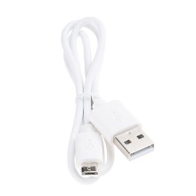Connect one end of the USB cable to the Photon device and the other your computer.

## Step 7

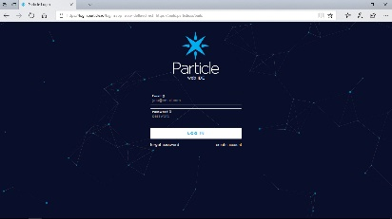Open your browser and navigate to <https://build.particle.io>. If not logged in enter the credentials given to you at the beginning of the session or ask one of the helpers to log you into the developer portal.

## Step 8

Select the Code icon from the menu down the left side () and choose **Lab 1** from the list. Next, flash the code to your device by choosing the Lightning Bolt icon () from the menu.

## Step 9

The LDR sensor detects the amount of ambient light in the room and turns the LED on when it is dark. Test the circuit by covering the LDR with your hand or some dark object. When covered, the LED should turn on and when light is present, the LED should turn off.

The amount of light needed to turn the LED on and off is based on a threshold defined in the application. The LDR is on an analog port and the voltage varies with the amount of light. The software reads the voltage from the analog port as a value between 0 and 4096. In the application, there is a variable called **LIGHT_THRESHOLD** that determines when to turn the LED on. As light is decreased, the voltage drops, and so does the value read from the analog port. When this value drops below the threshold, the LED is turned on. This threshold defines the devices overall sensitivity to light and can be adjusted.

Locate the LIGHT_THRESHOLD variable in the code and try changing the value to see the effect of differing levels of sensitivity (the default value is 100). Don’t forget to flash the code to your device each time your change the value.

# Lab 2